LAB Manual

Name of Student: Atharv Raje PRN: 22070122162 Semester: IV Year AY 23-24 Subject Title: Operating Systems Lab

EXPERIMENT No : 3 Assignment No: 4

TITLE : Basic Shell script for File operation DoP : 12/2/24

Name of Student: Atharv Raje PRN: 22070122162

Semester: IV Year AY 22-23 Subject Title: Operating Systems Lab

EXPERIMENT No : 4

TITLE: Basic Shell script for File operation DoP:12/2/24

*Aim :* Implement and demonstrate a shell script on file operations

*Learning Outcome: 1. To understand the shell script for file operation 2. To Demonstrate the shell script for file operations Hardware/Software*:

Procedure:

The steps to implement a basic shell script for file operations are:

1. Create a new file.

2. Edit the file using Text Editor and add the commands required for performing the desired file operations.

3. Save and close the file. The file extension should be .sh

4. Using the terminal, edit the permissions of the file to be executable using the **chmod** command

5. Run the script in the terminal using ./filename.sh

6. Based on the operations, provide the necessary inputs for the file operations. *Theory:*

*CODE:*

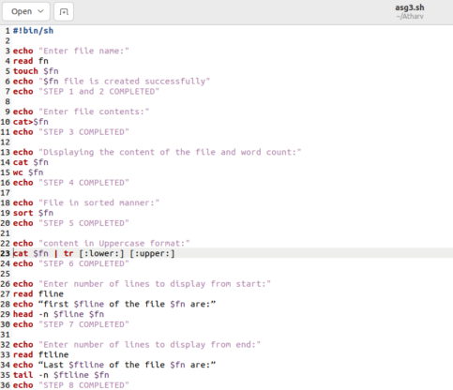

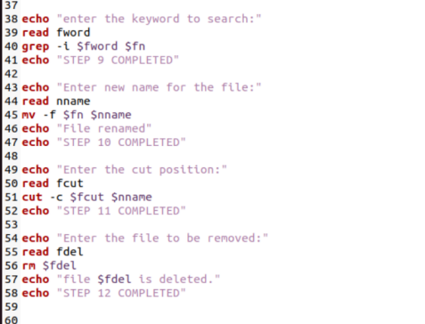

*Output:* snapshots of the demonstration:

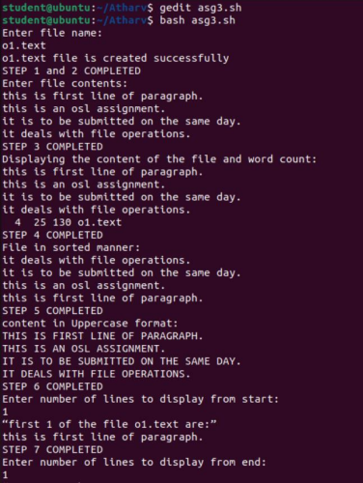

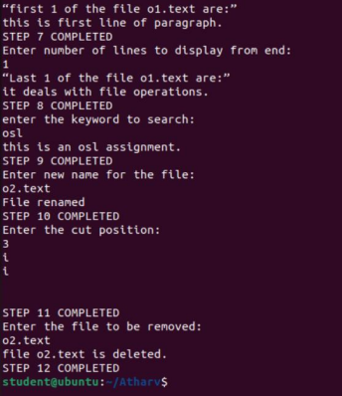

*Conclusion:*

Thus the commands used for file operations were studied using the shell script.

*assessment schemes.*

| Attendance | Discipline | Short oral | Correctness  of Lab Report | Timely  completion of Lab Report | Total  marks  (10) | Signature of Teacher with Date |
| --- | --- | --- | --- | --- | --- | --- |
|  |  |  |  |  |  |  |